Project Proposal
Multi-Organ Fish freshness detection App
Submitted By
Umair Habib – 231694
Daniyal Ibrahim – 222608
Muneeb Sajjad – 221045
Supervisor
Dr Fahad Tahir


Department of Computer Science
Air University Islamabad (AU)
Supervisor Meeting Log:
 | Discussion | Task Assignment | Supervisor Signature
Meeting 01  Date: 06-04- 2026 | Redefine modules, change existing modules with new ones | Implementing new modules and understanding the use of new modules
Meeting 02  Date: 06 - 05 – 2026 | Supervisor accepted new modules and suggested extra modules | Finalize The Modules

Table of Contents
1.Introduction 4
2. Related System Analysis 4
3. Problem Statement 7
4. Problem Solution / Objectives of the Proposed System 8
4.1 Objectives 8
5. Scope 9
6. Modules 10
7. System Limitations/Constraints 12
8. Data Gathering Approach 12
9. Tools and Technologies 13
10. Project Stakeholders and Roles 13
11. Module-based Work Division 14
12. Gantt Chart 15
13. Mockups 15
14. References 17

Introduction
Fish is an essential dietary component and a vital source of high-quality protein in Pakistan. However, its highly perishable nature means that freshness dictates not only its nutritional value and taste but also its safety for human consumption. Traditionally, assessing this freshness relies entirely on human sensory evaluation, inspecting the clarity of the eyes, the color of the gills, skin texture, and odor. This manual process is heavily subjective, prone to human error, and heavily dependent on the individual's prior experience.

This project proposes a paradigm shift in how seafood is traded and consumed, transforming a simple digital scanner into a comprehensive, cloud-integrated digital platform. Moving beyond basic assessment, the platform empowers both everyday buyers and commercial vendors by instantly identifying local fish species and accurately determining their true freshness. More than just a verification tool, the application fosters a completely transparent marketplace. It actively crowd-sources user scans to generate live, color-coded heatmaps that guide consumers to the best local market areas, synchronizes real-time official prices to combat price-gouging, and features an interactive AI assistant to educate consumers and vendors alike and to share culinary and regulatory knowledge. By leveraging machine learning, computer vision, spatial mapping, and Large Language Models (LLMs), this fully online system will not only identify commonly consumed Pakistani fish species and calculate their freshness, but it will also provide a secure ecosystem. Supported by a scalable subscription model, this platform bridges the gap between modern innovation and traditional commerce, ultimately ensuring safer food and fairer trade.

2. Related System Analysis

Table 1. Related System Analysis
System/Technology Name | Weakness | Proposed Project Solution
FishVerify (App) | Only identifies fish species and provides fishing rules; does not check freshness or provides shelf-life, does not have GPS-integrated area recommendation for fresh fish or live market pricing synchronization. | Our cloud-based system integrates deep learning to identify common Pakistani species while simultaneously assessing freshness. Provides GPS-integrated smart market area recommendations based on scanned fish data. It also features live official market prices and an interactive AI Chabot for dynamic regulation and guidance related to all things fish.
Fishku (App) | Detects freshness but only for limited fish types studied in research; does not calculate freshness percentage or shelf-life;  not tailored for Pakistan’s commonly consumed fish; lacks crowd-sourced market intelligence. | Our solution handles multiple fish species popular in Pakistan, provides freshness with a confidence percentage, and utilizes user GPS data to generate live market area heatmaps, making it a highly practical online tool for daily market use.
Torrymeter (Hardware) | Expensive, specialized hardware that requires physical contact with the fish to measure dielectric properties. It only assesses freshness and fails to identify species, estimate shelf-life, or provide market data. | Our solution requires zero specialized hardware, relying entirely on a standard smartphone camera. It combines non-invasive visual freshness assessment with species identification, live pricing, and smart market heatmaps.
Electronic Noses / E-noses (Hardware) | These utilize metal oxide semiconductor sensors to detect volatile organic compounds (amines) emitted during decomposition. They are hardware-dependent, sensitive to background market odors, and lack species identification capabilities. | Our app uses non-invasive computer vision (CNNs) to assess visual freshness indicators (eyes, gills, skin), making it instantly accessible and immune to chaotic olfactory environments in open-air fish markets.
Smart Packaging / Sensors | Rely on colorimetric sensors integrated into packaging that turn colors based on pH changes caused by spoiled fish. This is entirely useless for open-air, unpackaged fish sold in traditional local markets. | Our platform is built specifically for open-air, traditional markets. It utilizes live camera feeds to assess raw, unpackaged fish in real-time, coupled with a crowdsourced ecosystem to track market quality dynamically.
Microneedle Sensors (Hardware) | Specialized invasive sensors that physically penetrate the fish to detect hypoxanthine (HX) levels as low as 500 parts per billion in about 100 seconds. They require specialized lab-grade equipment not viable for everyday consumers or vendors. | Our app offers a completely non-invasive, instantaneous visual assessment (under 2 seconds) directly via a mobile application, requiring no physical penetration of the product and no specialized chemical sensors.

3. Problem Statement

In Pakistan, fish is widely consumed, but there is no reliable, fast, and standardized method to determine its freshness in markets. Buyers and sellers usually rely on visual inspection, smell, or personal experience, which is subjective and prone to errors, leading to the sale of rotten fish, potential health risks, and financial losses.
Furthermore, consumers face a significant transparency barrier. They lack real-time data on fair market pricing, making them vulnerable to price gouging. There is also no systemic way to know which markets are currently selling high-quality batches and which areas should be avoided due to spoiled inventory. Existing apps either focus only on species identification or detect freshness for a limited number of fish types, but none offer a holistic, data-driven cloud platform that crowd sources quality data, syncs live prices, and provides AI-driven guidance.

4. Problem Solution / Objectives of the Proposed System
To address the limitations in Pakistan’s current fish market and to effectively resolve the widespread reliance on subjective, error-prone visual inspections by both buyers and sellers, we propose the development of a highly integrated, comprehensive online Flutter-based application backed by robust cloud architecture that leverages image processing and a TensorFlow-trained machine learning model. This system will identify the species, assess the freshness of fish by providing a confidence percentage for freshness and estimate the shelf-life for the freshness. By doing so, the system will reduce human error, improve quality control, and offer a more reliable decision-making tool for buyers and sellers.
This platform will serve as a definitive digital tool for both consumers and vendors by replacing guesswork with data-driven AI assessment. By deploying TensorFlow-based Convolutional Neural Networks (CNNs), the application will instantly evaluate multi-organ visual indicators to determine freshness and identify specific local fish species. The user-friendly interface will cater to all technical skill levels, enabling easy image capture or upload, while AI Chabot will guide users through every step in using the app and explaining the scan results. Furthermore, the solution transcends a simple scanning utility by establishing a transparent market ecosystem. It introduces a live, crowd sourced feedback loop where user scans actively generate geographic heatmaps, instantly identifying market areas with high-quality inventory and warning others of degraded batches. Coupled with real-time official price synchronization directly from government or fishery portals, this platform empowers buyers to make safe, cost-effective, and informed decisions while providing honest vendors with a standard to prove their inventory's quality. This solution aims to enhance fish market practices, ensure safer consumption, and provide a practical, data-driven tool for the industry.

4.1 Objectives
• To engineer a highly optimized, mobile-ready CNN model capable of identifying local Pakistani fish species and detecting freshness through precise multi-organ (eye and gill) analysis.
• To calculate and display a real-time freshness confidence percentage alongside an estimated shelf-life.
• To implement a Smart Market Area Recommendation system that maps user scans via GPS, generating a dynamic heatmap to guide buyers toward fresh fish and away from spoiled batches.
• To dynamically fetch, synchronize, and display live official fish prices from local authorities to combat price manipulation.
• To deploy an LLM-powered AI Chabot that serves as an interactive assistant for user queries regarding app use, seafood storage, local maritime laws, recipes and all things fish.
• To develop a secure Subscription/Premium Access module with payment gateway integration, managing free-tier daily usage limits and offering premium unlimited scanning access.

5. Scope
The scope of this project encompasses the end-to-end architecture, design and deployment of a sophisticated, multi-tier cloud platform focused on the Pakistani seafood market. The application caters to a dual user base; everyday consumers seeking quality assurance and fair pricing, and commercial vendors or fishmongers aiming to digitally validate their stock. The frontend will be a cross-platform mobile application developed using Flutter, ensuring seamless operation across both Android and iOS devices. The system is designed as a fully online platform; thus, an active internet connection is strictly required for cloud database synchronization, AI model inference, live mapping, and API fetching. Users can capture or upload fish images, and the system will automatically identify the species, determine freshness with a confidence percentage, and estimate the time till the fish remains fresh (shelf-life). The application will enhance user experience with a simple and intuitive interface, providing easy access for users of all technical skill levels. The machine learning image processing will be exclusively trained on and constrained to commonly consumed local fish species, specifically Salmon, Rohu, Pomfret, Sulemani, Dayya and Sufaid Rohu. The Smart Market Area Recommendations will be functionally limited to areas where sufficient active users are scanning fish, relying heavily on the Google Maps API and user-granted device GPS permissions. The embedded AI Fishery Chatbot will be contextually restricted to topics concerning local fishery guidelines, maritime laws, fish recipes, safe storage techniques, and in-app navigation assistance. The system will not include offline scanning capabilities, nor will it support IoT hardware integrations or physical supply chain tracking. The live pricing module is dependent on the availability of public data from local authorities and will only reflect areas where such data is digitally published. The platform aims to reduce human error, improve market quality control, and ensure safer fish consumption by empowering users with real-time AI scanning and market intelligence.

6. Modules

6.1 Species Detection
- Utilizes a Convolutional Neural Network (CNN) specifically trained on extensive datasets of native Pakistani fish.
- Actively pre-processes the user's live camera feed or uploaded image to analyze unique morphological patterns, scale textures, and fin structures.
- Accurately classifies the scanned fish into distinct local categories (Rohu, Salmon, Dayya, Sulemani, Pomfret, Sufaid Rohu , anchovy , horsemackerel).
- Outputs the final classification result accompanied by a highly accurate statistical confidence score.

6.2 Fish Freshness Detection
- Employs highly specialized computer vision techniques to automatically isolate and analyze ocular and branchial indicators (e.g., eye clarity, gill color, and skin texture).
- Feeds localized metric data into the trained machine learning model to determine the exact degradation level of the fish.
- Classifies the fish as either 'fresh' or 'spoiled' based on biological indicators.
- Provides a real-time freshness confidence percentage and calculates an estimated shelf-life or time until fish starts spoiling.

6.3 Smart Market Area Recommendations
- Utilizes device GPS data and mapping APIs (such as Google Maps API) to connect AI assessments with real-world spatial utility.
- Tracks and aggregates geolocation data continuously in the cloud database as multiple users scan fish across various local market areas.
- Automatically generates a dynamic, color-coded "Heatmap" on the app's central dashboard based on crowd-sourced scan data.
- Highlights specific market sectors in green where users frequently scan high-quality, fresh fish, effectively recommending these areas to potential buyers.
- Highlights areas in red where highly spoiled fish are consistently detected, explicitly alerting users to avoid market sectors currently selling bad batches.

6.4 Live Market Price Synchronization
- Continuously monitors and tracks the daily market prices of various fish species to combat price gouging and ensure fair trade.
- Connects the backend system to official local fishery or market websites via RESTful APIs and automated web scraping scripts.
- Instantly synchronizes price fluctuations within the cloud database the moment they are updated on the official source website.
- Pushes updated live pricing directly to the Flutter mobile app, allowing consumers to actively cross-check a vendor's asking price against the standard daily rate in their area.

6.5 AI Fishery Chatbot
- Integrates a Large Language Model (LLM) to act as an on-demand, interactive fishery expert directly within the application.
- Provides instant, conversational answers regarding seasonal fishing bans, maritime regulations, and legal compliance in Pakistan.
- Gives all kind of information regarding the diversity of fish species and the types of fish available in certain seasons, acting as an encyclopedia for all things fish.
- Offers localized guidance on optimal freezer storage techniques and traditional culinary recipes specific to the fish the user just scanned.
- Acts as an in-app support guide to troubleshoot issues, explain application features, understanding scan results and improve the overall user experience.

6.6 Subscription/Premium Access
- Implements a freemium business logic architecture to transform the application into a commercially scalable SaaS (Software as a Service) platform.
- Manages distinct user tiers and enforces database-level usage limits, restricting free-tier users to a strict quota of daily online fish scans.
- Integrates secure payment gateways (such as Google Play Billing, local bank, or local alternatives like sadapay and jazzcash) to handle subscription transactions smoothly.
- Unlocks a Premium Access tier upon successful payment, which removes the daily quota and grants users (such as commercial buyers or heavy consumers) the ability to perform an unlimited number of fish scans.

7. System Limitations/Constraints
• As a cloud-integrated platform, the application requires an active internet connection to perform machine learning inference, load heatmaps, fetch live prices, and chat with the AI.
• The system cannot guarantee 100% accuracy in freshness detection or species identification; factors like poor lighting or unclear images can reduce prediction accuracy.
• The Smart Market Area Recommendations depend entirely on users granting GPS permissions and the availability of Google Maps API services. Heatmaps require a critical mass of active users in an area to be statistically useful.
• The AI Fishery Chatbot and Live Market Price Synchronization rely on the continuous uptime and rate limits of external LLM providers and official pricing websites.

8. Data Gathering Approach
Data collection for this project was a challenging and time-consuming process, as the system requires a diverse and accurately labeled dataset for both fish freshness detection and species identification. Considerable effort was dedicated to understanding the visual indicators of fish freshness and gathering suitable image data for model training.

The dataset will primarily be collected from publicly available academic and machine learning repositories, including Kaggle and Mendeley Data. These platforms provide high-quality datasets containing images of fresh and spoiled fish, along with multiple fish species commonly used in computer vision and deep learning research.
The collected images include variations in lighting conditions, viewing angles, backgrounds, and environments to improve the robustness and generalization capability of the CNN model. The dataset focuses on important visual freshness indicators such as eye clarity, gill color, skin texture, and overall body appearance. Species-specific images will also be used to train the fish classification module.To further improve localization and real-world accuracy, limited custom images may also be captured from local fish markets in Pakistan. This will help the system better recognize commonly consumed Pakistani fish species and adapt to practical market conditions..

9. Tools and Technologies
Table 2. Team Member Work Division for Proposed Project
Tools And Technologies | Tools | Rationale
Tools And Technologies | Flutter | Frontend / Mobile App Development
Tools And Technologies | Dart | Frontend / App Logic
Tools And Technologies | Python | Backend Development & Model Training
Tools And Technologies | TensorFlow | Machine Learning / Model Training
Tools And Technologies | Firebase Google cloud | Online Database
Tools And Technologies | Google map | Backend
 | Android Studio / VS Code
  IDE / Development

10. Project Stakeholders and Roles
Table 3. Team Member Work Division for Proposed Project
Project  Sponsor | Air University Islamabad
Stakeholder | - Umair Habib  - Daniyal Ibrahim  - Muneeb Sajjad  - Dr Fahad Tahir (Supervisor)  - Final Year Project Committee: Evaluation of project

11. Module-based Work Division
Table 4. Member Work Division for Proposed Project
Student Name | Student Registration Number | Responsibility/ Module / Feature
Umair Habib | 231694 | Data gathering from online sources and markets, image preprocessing, dataset preparation, and labeling fish species and freshness levels.
Daniyal Ibrahim | 222608 | - Backend –  Machine learning model development using Python and TensorFlow, training and testing the model for species identification, freshness detection, and confidence prediction.
Muneeb Sajjad | 221045 | - Frontend –  Flutter mobile application development, designing the user interface, integrating the trained model with the app, and implementing the online database (Firebase) for fetching data

12. Gantt Chart
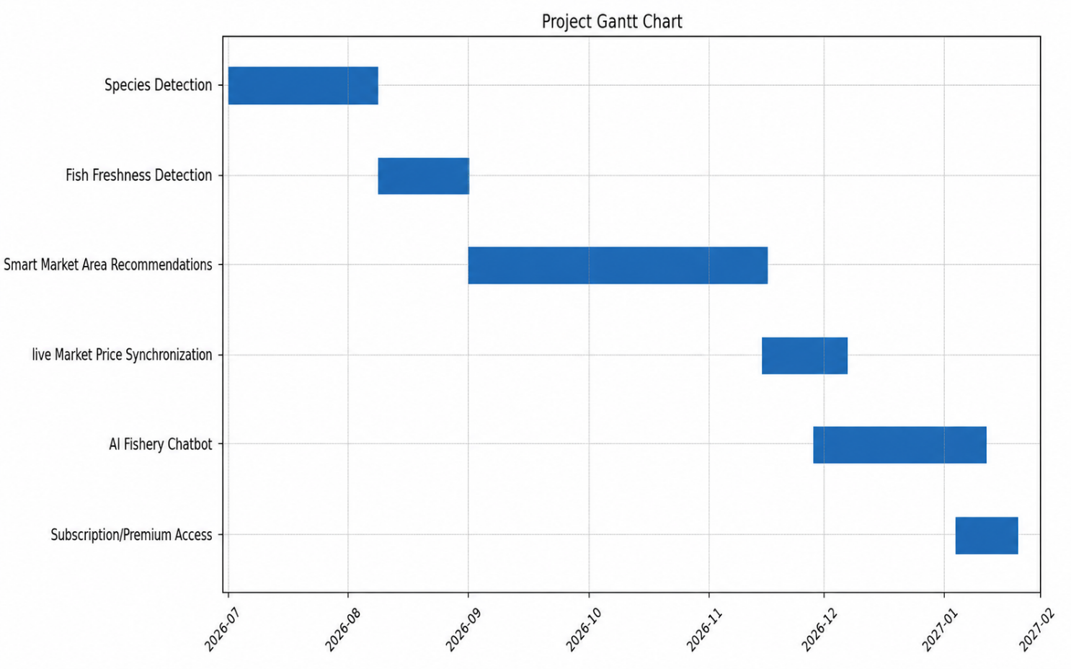

Figure 1. Gantt chart of Fish Freshness

13. Mockups
Profile Page
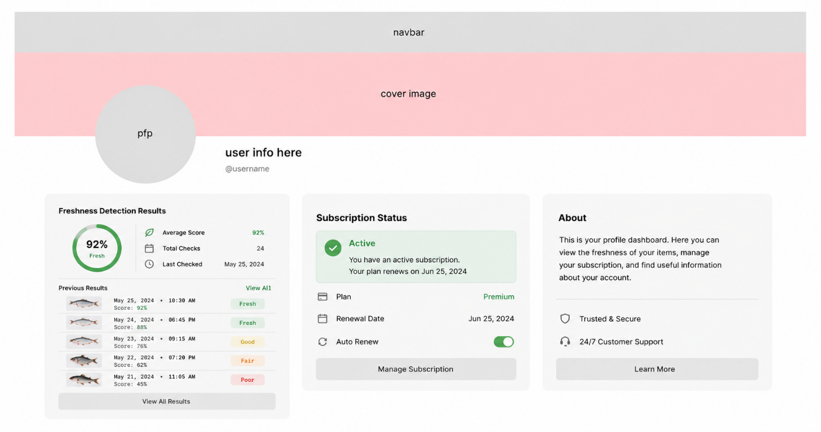
Figure 2. Profile Page
Description: Allows the user to see subscription status , past results with average score , about section and manage profile
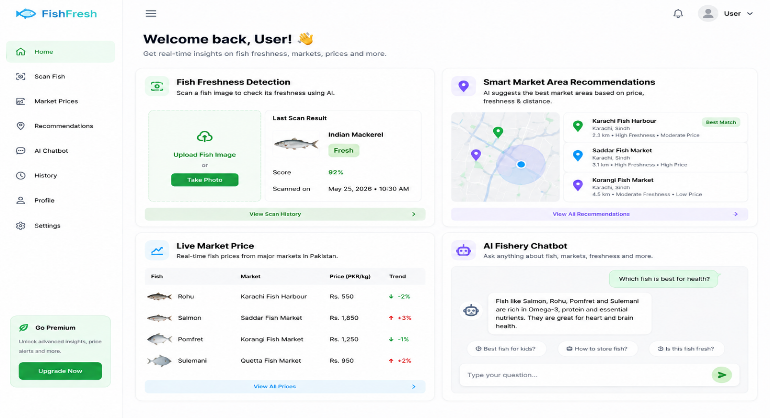
Figure 3.Main page
Description: This page allows users to detect fish freshness, tracking live market prices, recommending nearby fish markets in Pakistan, and assisting users through an intelligent fishery chatbot

14. References

A. Alaimahal, S. Shruthi, M. Vijayalakshmi, and P. Vimala, “Detection of Fish Freshness Using Image Processing,” International Journal of Engineering Research & Technology (IJERT).
Available: https://www.ijert.org/detection-of-fish-freshness-using-image-processing

S. M. Hamidy, Y. Kuvvetli, Y. Sakarya, S. T. Özkütük, and Y. Özoğul, “Deep Learning-Based Prediction of Fish Freshness Using Image Data,” Foods.
Available: https://www.mdpi.com/2304-8158/15/1/68

